Stop it or not? Effects of platform governance on firms’ online review manipulation

**Abstract:** E-commerce firms engaged in online review manipulation mislead online consumers in their purchasing decision-making and undermine the credibility of the platform they are using. Although researchers have proposed various measures to combat review manipulation, few studies have considered platforms’ revenues from an economic perspective and explored how platforms affect the review manipulation of two asymmetrical firms. To fill this research gap, this paper develops a three-player game model to systematically explore the impact of review manipulation governance imposed by a platform on itself and on two asymmetrical firms offering substitutable commodities on the same platform. The results reveal that governance helps firms avoid situations in which they should engage in manipulation due to competitive pressures. Furthermore, even in the presence of governance, both firms may become trapped in a prisoner’s dilemma. Even if the platform imposes review manipulation governance, both firms and the platform can benefit from manipulation. We also consider the temporal effects of governance on the platform’s revenue and validate whether it is beneficial for the platform to impose review manipulation governance in the long run. Quantitative analysis is conducted to elucidate the benefits that can be attained by the three parties under different circumstances. This analysis holds practical significance for e-commerce platforms and firms seeking to impose appropriate measures pertaining to review manipulation.

**Keywords:** Review manipulation, platform governance, three-player game model

1. Introduction

The significant impact of online product reviews on consumers’ purchasing decisions has led to the manipulation of reviews by online firms operating in the e-commerce industry. E-commerce firms are often tempted to manipulate online reviews to gain a competitive edge in the online market. A survey showed that 87.0% of respondents stated they had been fooled by fraudulent reviews, with 12.2% saying they had done so several times. Moreover, 84.7% of the respondents confirmed that the high number of fake product evaluations on an e-commerce platform affects its credibility evaluation[1]. Online review manipulation not only hurts a platform’s credibility but also leads to substantial economic loss for stakeholders [1]. The results of a survey conducted by the Federal Trade Commission revealed that online review manipulation generated a total loss of US$32.8 billion in the United States in 2019, accounting for approximately 5% of all e-commerce transactions[2]. Thus, to combat review manipulation, platforms have become increasingly involved in governance efforts to ensure the quality of online reviews and preserve consumer trust, which is essential for their sustainable revenue model. For instance, in July 2021, Amazon shut down numerous Chinese firms engaged in review manipulation, including Patozon, Aukey, and Tomtop[3]. In 2021, Yelp removed over 210,000 fraudulent reviews through its internal filtering algorithm[4].

Existing research has examined the impact of firms’ review manipulation on their rivals as well as the review manipulation governance enforced by platforms. Regarding the former aspect, studies have revealed the diverse effects of firms’ strategic review manipulation on their rivals. For example, Mayzlin et al. [2] demonstrated that hotels located near competitors tend to receive more fake negative reviews than those without nearby rivals. Cao [3] discovered that firms’ review manipulation behaviors do not necessarily impact their rivals’ profits; furthermore, a prisoner’s dilemma may arise when firms have the freedom to choose whether to manipulate online reviews. In the latter aspect, the current body of research has unveiled specific review manipulation governance measures implemented by platforms. For example, Cheng et al. [4] proposed a novel framework based on graph neural networks for detecting spam senders by learning user representations within social context networks. Riazati et al. [5] found that platforms can combat review manipulation by adopting mechanisms that promote honesty, including direct reward and punishment systems.

Although previous studies have discussed issues related to online review manipulation and platform governance, many often treat these two aspects separately. Specifically, when investigating the impact of review manipulation on firms, researchers often overlook the restraining effect of platform governance. While the existing literature has proposed various methods for platforms to combat manipulated reviews, these methods often only consider the technical or regulatory measures that can be taken by platforms without fully considering the impact of such measures on firms’ behaviors and the platform itself. Thus, the focus of the current paper is to investigate the interaction between a platform’s governance and two asymmetric firms’ review manipulation. Considering the intervening role of platform governance in review manipulation, this paper intends to examine three important research questions (RQs):

*(1) What is the impact of platform governance on the manipulation of competitive firms?*

*(2) Under the governance of a platform, who can benefit from online review manipulation?*

*(3)* *When considering long-term impacts, under what circumstances will a platform choose to implement governance?*

To address these RQs, this paper develops an analytical model in which two asymmetrical firms (i.e., superior and inferior) sell substitutable search products through a common platform. To emphasize the importance of online reviews, this paper assumes that all consumers’ judgments about products are derived from online reviews. These two asymmetric firms sell products of the same actual quality; however, the perceived quality reflected in unmanipulated reviews differs. The firm with higher quality, as revealed by unmanipulated online reviews, is referred to as the “superior firm,” while the other firm is referred to as the “inferior firm.”

We then developed a three-player game model, which involved a superior firm, an inferior firm, and a platform, to examine how platform governance affects review manipulation. First, we defined the profit functions for the superior firm, the inferior firm, and the platform under different review manipulation scenarios, depending on whether the platform chose to enforce governance. The scenarios included “no manipulation,” “manipulation by the inferior firm alone,” “manipulation by the superior firm alone,” and “simultaneous manipulation by both firms.” After deriving the profit functions, we conducted a comparative analysis of the decisions made by the superior firm, the inferior firm, and the platform under each scenario. Our analysis revealed that when a platform implements governance, a firm may opt not to manipulate, even if its competitor does, without negatively impacting its profits. Governance enables firms to avoid the need to manipulate under competitive pressure. Furthermore, our results revealed that even in the presence of governance, the scenario in which both firms engage in manipulation is not always the globally optimal solution; instead, this scenario (i.e., both firms choose to manipulate) can lead them into a prisoner’s dilemma. Finally, by considering the long-term effects of governance on the platform, we discover that governance may not always represent the optimal solution for it. Furthermore, the benefits derived from governance tend to level off over time.

This paper makes three significant contributions to the literature. First, it constructs a three-party game model to systematically explore the impact of platform governance on the manipulation of online reviews by asymmetrical firms, thus addressing a gap in the existing literature regarding governance effects from the perspective of platforms’ economic interests. By incorporating the platform into the game model, this research not only analyzes competitive behavior between firms but also reveals how the platform—as a strategic participant—can maximize its interests by formulating appropriate governance strategies. This finding contrasts with previous studies that predominantly focus on firms’ profits or those of their competitors [3,6,7].

Second, the present study reveals that firms’ review manipulation does not necessarily harm the profits of a platform and its competitors. Through quantitative analysis, we demonstrate the platform’s profits in different scenarios, proving that it can find an appropriate “profit maximization governance” strategy by balancing governance costs and benefits. Furthermore, in the presence of platform governance, a firm does not need to continuously engage in manipulation to increase its profit, even when its competitor is engaged in review manipulation.

Finally, by analyzing the long-term effects of varying governance intensities and time on platform and firm behavior, the present study reveals that the platform may not implement governance measures from the outset. Furthermore, as time progresses, the intensity of governance tends to increase, and the additional benefits brought by governance to the platform will not grow indefinitely. Instead, the platform’s profits will stabilize. This finding provides practical insights for e-commerce platforms in terms of addressing review manipulation issues, enabling them to develop more effective long-term governance strategies.

The remainder of the paper is organized into sections. Section 2 presents a review of the literature related to review manipulation and platform governance. Section 3 describes the model used in this paper. Section 4 develops the profit function of the two firms and the platform and analyzes the effect of manipulation under different scenarios. Section 5 concludes the paper.

1. Literature review
   1. Online review manipulation

Competitive advantages and increased profits through online review manipulation motivate firms to engage in such practices. Studies have shed light on the impact of review manipulation on firms. For example, Luca and Zervas [8] examined online reviews on the Yelp platform and revealed that restaurants with weaker reputations or those facing heightened competition were more prone to engage in review fraud. Guo et al. [9] demonstrated that manipulated first-party reviews had a positive impact on firms, whereas third-party reviews can be detrimental.

Researchers have also examined the effects of firms’ review manipulation on their competitors, apart from its impact on the firms themselves. Lappas et al. [10] found that as few as 50 fraudulent reviews can enable a firm to surpass any of its competitors in electronic word-of-mouth communication. Li et al. [11] demonstrated that a firm’s manipulation strategy, either covert or overt, could harm the interests of its competitors in two distinct ways. However, competitors’ retaliation may impede a firm’s ability to manipulate reviews, ultimately boosting these competitors’ profits. Furthermore, in a competitive market, superior and inferior firms may adopt different strategies for review manipulation. Compared to superior firms, those with lower average ratings and inferior market positions are more inclined to engage in manipulated reviews [1,7,12].

Thus far, existing research has not only analyzed the impact of manipulation on the firms themselves and their competitors but has also examined its effects on consumers and the platform. For instance, Chen et al. [13] developed a micro-behavioral model to analyze the conditional-rebate strategy on sellers. Their results revealed that although conditional rebate strategies may lead to fake reviews, this is not always the case. In certain situations, such strategies can even increase consumer surplus and social welfare. Mostagir and Siderius [14] proposed a dynamic two-sided reputation model to explore the impact of bribes on reviewers’ credibility. Furthermore, they found that simply reducing bribery through regulatory policies may lead to adverse outcomes because, in certain cases, appropriate bribes can enhance consumer utility through the implementation of second-best information transmission.

Although existing studies have made significant advancements in understanding the effects of online review manipulation on firms, platforms’ regulatory role in review manipulation has often been ignored. Given that platform governance interventions may alter merchant behavior strategies in real-life scenarios, the current paper investigates the impact of platform governance on firms’ review manipulation. In doing so, this work provides new insights and theoretical support for understanding the interactive relationship between firm review manipulation and platform governance.

* 1. Platform governance of review manipulation

The governance imposed by e-commerce platforms has proved effective in counteracting online review manipulation. In the realm of e-commerce, platforms are necessary to regulate firms’ manipulative behaviors, as review manipulation would hurt platforms’ revenue by exacerbating the information asymmetry between online firms and potential consumers [15–17].

To combat review manipulation, platforms have developed various governance measures, such as internal filtering algorithms, and imposed penalties on firms that engage in review manipulation. On the one hand, these internal filtering algorithms have been verified as effective tools for addressing the challenge of review manipulation. For example, Amazon deployed robust technological tools and algorithms to detect fraudulent reviews, thus mitigating firms’ review manipulation through the use of these filtering algorithms[5]. Similarly, many studies have explored fraudulent review detection methods to help platforms combat review manipulation [18,19]. On the other hand, some studies have revealed that platforms can impose controllable penalties on firms to govern review manipulation. For example, Mayzlin [2] claimed that a review-hosting platform could combat review manipulation by punishing exposed firms engaged in review manipulation and those that violate competition rules. Ananthakrishnan et al. [20] concluded that platforms can protect consumers and firms by punishing dishonest firms rather than filtering suspicious fraudulent reviews. Despite significant efforts by many scholars to explore various methods for enhancing the effectiveness of platform governance, they have not incorporated an analysis of firm behaviors.

At the same time, researchers have also analyzed and demonstrated that stricter regulation may not always be better for e-commerce platforms. From the perspective of ranking mechanisms, Jin et al. [21] investigated the effects of firms’ placing fake rankings of their products to manipulate sales volumes on social welfare by considering two firms selling substitutable products. Their findings suggest that stricter platform policies may harm consumers. Specifically, increasing the cost of “brushing” may discourage high-quality merchants from engaging in manipulation while simultaneously incentivizing low-quality merchants to intensify their manipulation efforts. Chen and Papanastasiou [22] examined the interaction between social learning manipulation and equilibrium market outcomes and demonstrated that increasing the intensity of antimanipulation measures (i.e., detecting and punishing misconduct) can lead to unintended consequences, often inducing higher levels of manipulation and higher equilibrium prices.

Actually, the revenue generated for platforms is a significant factor driving their regulatory effort investments. Long and Liu [23] focused on a case involving two firms competing with each other and a platform attempting to maximize its own revenue by review manipulation. They found that platform manipulation increased the comparability of an inferior firm to a superior firm. Thus, with the increasing competition between these firms, the platform can profit from them through advertisement charges. However, they did not consider a more widespread real-world practice in which firms engage in manipulation while the platform imposes governance.

In the present study, we analyze the impact of review manipulation from a platform’s perspective and explore the conditions under which it chooses to implement governance. In our model, the platform’s decision-making is driven by the need to balance short-term gains from short-time increased transactions and prices with the long-term benefits needed to maintain a trustworthy ecosystem. This comprehensive perspective not only advances theoretical understanding but also provides practical guidance for platforms in formulating governance strategies that aim to balance regulatory effectiveness with economic viability.

1. Model setup
   1. Consumer utility

Our study aims to capture both firms’ review manipulation strategies and the platform’s governance strategies under various scenarios, following a modeling approach commonly adopted in the literature [3,2,24]. This paper assumes two competitive firms (firm A and firm B) on an e-commerce platform. Firm A sells product A at a price  and firm B sells product B at a price . For simplicity, we assume that the market is fully covered. In other words, each consumer on this platform will choose either product A or product B, which will increase their utility. In this paper, we assume that these two products are substitutable search products. The reason we focus on search products is that review manipulation always boosts the sales of such products by improving their average review ratings, thus altering consumers’ perceptions of product quality [25,26].

Each search product has two characteristics: “quality” and “fit attributes.” The quality attribute describes the perceived quality of a product and can be denoted as . Given that the object of our study is substitutable products, we assume that the true quality difference between the two products is zero and that each consumer only chooses one product. Although both products have the same true quality, consumers have different perceived qualities. To simplify, we assume that consumers’ perceived quality is entirely derived from online reviews. This assumption aligns with previous studies [27,28], which demonstrated that online reviews serve as a primary information source for consumers to make purchase decisions. The present paper uses  to describe the original quality difference between the two products, as revealed by unmanipulated online reviews. Considering the symmetry, this paper only considers the case wherein  and refers to firm A as a “superior firm” and firm B as an “inferior firm.”

In addition, these products have different degrees of misfit with consumers who have heterogeneous preferences. Given the long-term nature of the platform, it is essential to account for its long-term effects. According to a recent report[6], the number of online consumers in China has remained relatively stable in recent years. To better reflect real-world conditions, this study assumes a stable market environment in which the total number of online consumers remains constant. We also set the initial number of consumers on the platform to 1. Following existing studies [3,6,17], the paper uses the Hotelling line framework to capture consumers’ heterogeneous preferences. We assume that the products are located at the two end points of a hoteling line of unit length, with product A at 0 and product B at 1. This paper also considers that consumers are uniformly distributed over the interval [0,1]; thus, the distance between a product and a consumer measures the degree of misfit of the product to the consumer. When consumers purchase a product that deviates from their preference, they incur a misfit cost. The misfit cost is modeled as the degree of misfit  times a unit misfit cost .

A consumer’s net utility, denoted by  is equal to the maximum utility of the product derived by a consumer from the product. If consumers are located at , their respective net utilities derived from product A and product B are as follows:

|  |  |
| --- | --- |
| . |  |

The net utility difference between product A and product B for the consumer is derived by

|  |  |
| --- | --- |
| . |  |

* 1. Review manipulation

Firms can manipulate reviews to change consumer perceptions, ultimately boosting their profits. This paper considers only the positive reviews a firm posts about itself and does not include malicious negative reviews from its competitors. Furthermore,  and  are the quality improvements attained by firm A and firm B through their review manipulations, respectively. Thus, when the superior firm manipulates alone, the quality difference revealed by online reviews is ; when the inferior firm manipulates alone, the quality difference revealed by online reviews is ; and when both firms manipulate, the quality difference revealed by online reviews is . In this paper, we assume that consumers fully trust online reviews and are unable to identify manipulated reviews. When a firm chooses to manipulate, its cost is  (*i*=A or B), where  is denoted as the cost coefficient of manipulation. We used this designation because the cost of review manipulation is a convex function of its effort [2]. Therefore, the net utility difference between product A and product B is shown in Eq. (3). In this formula, =0 or 1 corresponds to different scenarios:

|  |  |
| --- | --- |
| . |  |

* 1. Platform governance

As the third player of the game model, the platform can play a governing role in combating review manipulation. In this paper, we use  to denote the platform’s governance intensity. Although we previously assumed that the total market size remains constant, varying levels of governance have a direct impact on user experience and trust in the platform, which, in turn, affects consumer retention or attrition. Consequently, by adopting appropriate regulatory strategies, the platform may face certain short-term implementation costs. However, in the long run, it can enhance overall trust, thereby stabilizing or increasing the number of consumers. This scenario implies that the platform should balance short-term gains and long-term benefits in decision-making to determine the optimal governance intensity that increases long-term outcomes. In the long term, governance leads to an increase in the number of consumers, with a growing impact over time. In this work, we denote the increase in consumer numbers as , where  represents consumer sensitivity to governance, and  is the time. At this point, the total number of consumers on the platform increases from 1 to . At the same time, due to the presence of governance, the platform can detect manipulated reviews [29,30] and promptly remove them once identified, thus reducing the extent of manipulation by firms. Notably, most platforms are unable to detect all fraudulent reviews, and the accuracy rates of many state-of-the-art algorithms fall within a certain range, usually between 85% and 95% [31]. Thus, the review manipulation efforts exerted by firms are reduced to , where  denotes the proportion of fraudulent reviews that remain on the platform. In the existence of platform governance, the net utility difference between product A and product B for the consumer is presented as Eq. (4), where = 0 and =1 represent the scenarios of no governance and governance by the platform, respectively.

|  |  |
| --- | --- |
|  |  |

We consider that the platform’s primary revenue sources are the commission fees generated from the sales of firms A and B. Let  denote the commission proportion of the income from firms. When the platform chooses to govern, it incurs the costs associated with its governance intensity. This is because, with an increase in filtering intensity, many reviews may be identified as fraudulent, thus causing labor costs, such as secondary reviews. In addition, is used to denote the cost of the governance, where  is the cost coefficient of the platform governance intensity. When the platform decides to implement governance, firms’ manipulative behavior will also incur additional penalty costs for themselves [32].

Furthermore,  represents the intensity of governance implemented by the platform. As  increases, the platform’s regulatory enforcement intensifies, thus leading to greater penalties for firms due to their manipulative behaviors. Therefore, the penalty resulting from firms’ manipulation can be represented as . Although firms’ manipulative behaviors result in additional penalty costs, the platform does not include the revenues generated from these penalties in its total income calculation. This is because, relative to the platform’s total revenue, the income from penalties is typically negligible [32].

* 1. Demand function

To calculate the demand of firms, we first derive the location of indifferent consumers , who are indifferent between purchasing product A and product B. Here, the equilibrium point of consumer demand is reached when both products provide the same utility, that is, . Thus, the indifferent consumer  satisfies the following: . We can obtains  using Eq. (5) below:

|  |  |
| --- | --- |
| . |  |

From this, the demands of firms A and B are calculated as  and , respectively. Therefore, the corresponding demand functions for each firm are shown in Eq. (6):

|  |  |
| --- | --- |
| , |  |
| . |

* 1. Timing of the game

The process of this game model is as follows. In stage 1, the platform decides whether or not to impose manipulation governance. In stage 2, firms A and B decide whether or not to manipulate reviews. In stage 3, both firms set their prices and manipulation efforts. Finally, consumers choose between purchasing product A or product B. This paper considers eight scenarios. In particular, when the platform chooses to govern, there are four scenarios: no manipulation, manipulation by firm A alone, manipulation by firm B alone, and manipulation by both firms. When the platform chooses not to govern, the same four scenarios apply. Table 1 summarizes the notations used in the paper.

Table 1. Summary of notations

|  |  |
| --- | --- |
| **Decision Variables** | |
| Notation | Definition |
|  | The price of product |
|  | The manipulation effort of firm |
|  | The governance intensity of the platform |
| **Parameters** | |
|  | is the cost coefficient of manipulation, while  is the cost coefficient of the platform governance |
|  | The degree of misfit between a consumer and product A |
|  | Unit misfit cost |
|  | Time |
|  | The quality difference perceived by consumers through unmanipulated online reviews |
|  | The proportion of revenue that firms can retain after deducting commissions |
|  | The proportion of fraudulent reviews that remain on the platform |
|  | The consumer sensitivity to governance |
|  | Demand for product |
|  | , demand for the product  without manipulation based on whether or not the platform chooses to govern |
|  | , profits of firm A, firm B, and the platform without manipulation based on whether or not the platform chooses to govern |
|  | Demand for the product  with manipulation by firm A alone based on whether or not the platform chooses to govern |
|  | Profits of firm A, firm B, and the platform with manipulation by firm A alone based on whether or not the platform chooses to govern |
|  | Demand for the product  with manipulation by firm B alone based on whether or not the platform chooses to govern |
|  | Profits of firm A, firm B, and the platform with manipulation by firm B alone based on whether or not the platform chooses to govern |
|  | Demand for the product  with manipulation by both firms based on whether or not the platform chooses to govern |
|  | Profits of firm A, firm B and the platform with manipulation by both firms based on whether or not the platform chooses to govern |

To better illustrate the sequence of our game model, the game tree proposed in this paper is presented in Fig 1.

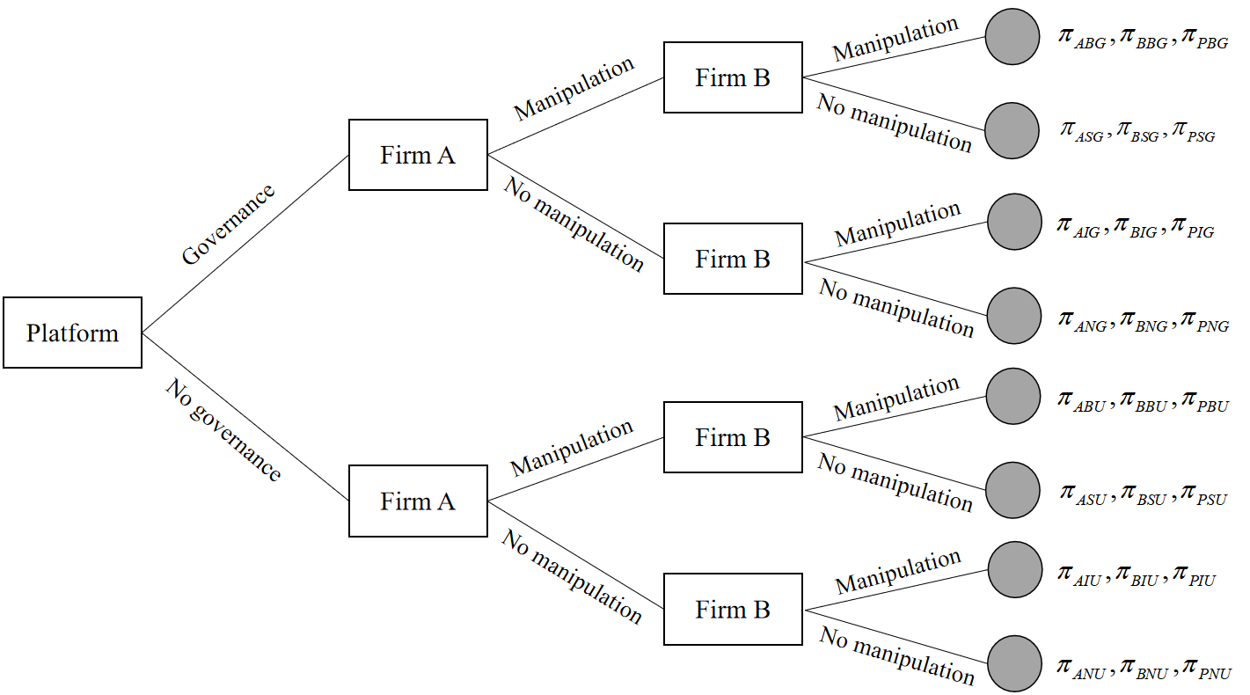

Fig 1. The game tree

1. Model analysis
   1. Impact without manipulation
      1. No platform governance

When there is no firm manipulation, based on Eq. (6), the respective demand functions of firm A and firm B are as follows:

|  |  |
| --- | --- |
| , | (7-1) |
| . | (7-2) |

The corresponding profit functions of firm A, firm B, and the platform are as follows:

|  |  |
| --- | --- |
| , | (8) |
| , |  |
| . |  |

Firms are dedicated to maximizing their profits by choosing optimal prices. As is customary in backward induction, the equilibrium prices of each firm are obtained based on the first-order conditions of the firms’ profit functions, as shown in Eq. (8).

**Lemma 1**

When no firms manipulate online reviews, the equilibrium prices and profits are respectively shown in Eqs. (9) and (10) as follows:

(a) Prices:

|  |  |
| --- | --- |
| . | (9) |

(b) Profits:

|  |  |
| --- | --- |
| , | (10) |
| , |  |
| . |  |

* + 1. Platform governance

When the platform chooses to govern, the respective demand functions of firm A and firm B are as shown in Eq. (11):

|  |  |
| --- | --- |
| , | (11-1) |
| . | (11-2) |

Furthermore, the profit functions of firm A, firm B, and the platform can be found in Eq. (12).

|  |  |
| --- | --- |
| , | (12) |
| , |
| . |

Firms are dedicated to maximizing their profits by choosing optimal prices, and the platform is dedicated to maximizing its profit by choosing the optimal governance intensity. As is customary in backward induction, we can obtain the equilibrium prices of each firm and governance intensity, as shown in Eqs. (13) and (14).

Lemma 2

When no firms manipulate online reviews under platform governance, the respective equilibrium prices and profits are presented as follows:

(a) Prices:

|  |  |
| --- | --- |
| . | (13) |

(b) Governance intensity:

|  |  |
| --- | --- |
| . | (14) |

(c) Profits:

|  |  |
| --- | --- |
| , | (15-1) |
| , | (15-2) |
| . | (15-3) |

* 1. The impact of manipulation by the superior firm
     1. No platform governance

When only firm A is engaged in manipulation, and there is no platform governance, based on Eq. (6), the demand functions of firm A and firm B can be respectively expressed in Eq. (16) as follows:

|  |  |
| --- | --- |
| , | (16-1) |
| . | (16-2) |

The profit functions of firm A, firm B, and the platform are respectively expressed in Eq. (17) as follows:

|  |  |
| --- | --- |
| , | (17-1) |
| , | (17-2) |
| . | (17-3) |

Firms are dedicated to maximizing their profits by choosing optimal prices. Based on the first-order conditions of Eqs. (17-1) and (17-2), the equilibrium manipulation effort for the superior firm and the equilibrium prices for each firm are obtained.

Lemma 3

When firm A manipulates online reviews alone without governance, the respective equilibrium prices, manipulation effort, and demands under the conditions of  and  are as follows:

(a) Prices:

|  |  |
| --- | --- |
| . | (18) |

(b) Manipulation effort:

|  |  |
| --- | --- |
| . | (19) |

(c) Profits:

|  |  |
| --- | --- |
| , | (20-1) |
| , | (20-2) |
| . | (20-3) |

This paper analyzes the manipulation decisions of both firms if the superior firm A manipulates online reviews alone. The outcomes are summarized in the following proposition.

Proposition 1

Under the manipulation by the superior firm alone, when the platform chooses not to govern:

(a) firm A will always benefit from its manipulation (i.e., ), and

(b) firm B will not choose to abstain from manipulation (i.e.,  has no solution).

When firm A chooses to manipulate, its manipulation cost  cannot be too low to ensure that both firms play a role in the equilibrium and make a positive profit simultaneously, which means ensuring that the prices and profits for firms A and B are both greater than 0. Proposition 1 (a) shows that manipulating online reviews is always profitable for the superior firm A if the inferior firm B does not manipulate online reviews. This result may be due to the positive manipulation by firm A, which will enhance its pre-existing reputation () as a superior firm. Furthermore, this would make firm A a monopolist in the market, which would always result in greater benefits for firm A than when it does not engage in manipulation. Furthermore, Proposition 1 (b) describes that  has no solution when firm A manipulates alone without governance. If firm A engages in manipulation alone, firm B as an inferior firm and without manipulation, will experience a sharp decrease in market demand and a subsequent decline in profit. Therefore, firm B will choose not to refrain from manipulation when firm A is also engaged in such a practice.

* + 1. Platform governance

When only firm A manipulates reviews and with the presence of platform governance, based on Eq. (6), the demand functions of firm A and firm B can be expressed in Eq. (21) as follows:

|  |  |
| --- | --- |
| , | (21-1) |
| . | (21-2) |

The corresponding profit functions of firm A, firm B, and the platform can be expressed in Eq. (22) as follows:

|  |  |
| --- | --- |
| , | (22) |
| , |
| . |

Both firms and the platform are dedicated to maximizing their profits by choosing optimal strategies. Based on the backward induction, we can obtain the equilibrium governance intensity, manipulation effort, and equilibrium prices as follows.

Lemma 4

When firm A manipulates online reviews alone and with the presence of platform governance, the equilibrium prices, manipulation effort, punishment intensity, and profits are as follows, with the condition of :

(a) Prices:

|  |  |
| --- | --- |
| , | (23) |
| . | (24) |

(b) Manipulation effort:

|  |  |
| --- | --- |
| . | (25) |

(c) Governance intensity:

|  |  |
| --- | --- |
| . | (26) |

(d) Profits:

|  |  |
| --- | --- |
| , | (27-1) |
| , | (27-2) |
| , | (27-3) |

where .

This paper then analyzes the manipulation decisions of the three parties if the superior firm manipulates online reviews alone. The results are summarized in the following propositions. The proof and all the notations that are not shown in Table 1 can be seen in Appendix A.1.

Proposition 2

Under the superior firm A’s manipulation alone and the platform’s governance, firm A will be better off compared to the scenario of no manipulation if and only if . Based on the profits we calculated in Eqs. (27-1) and (15-1), there are two cases satisfied:

(1) , ; and

(2) , , .

Proposition 3

Under firm A’s manipulation alone and the platform’s governance, the inferior firm B will choose not to manipulate if and only if  and . Based on the profits we calculated in Eqs. (27-2) and (49-2), there is one case we can consider:

(1) , , , .

Proposition 4

When firm A manipulates online reviews alone, the platform will choose to govern if and only if . Thus, based on the profits we calculated in Eqs. (27-3) and (20-3), there is one case we can consider: , .

For firm A,  is denoted as the manipulation cost coefficient that cannot be too low to ensure that the corresponding prices and demands for A and B are greater than 0. By manipulating reviews, firm A can enhance the attractiveness of its products, thereby increasing sales and overall revenue. Based on the range of , there are two cases where firm A can benefit from its manipulation, as shown in Proposition 2:

(1) When the unit manipulation cost is small (i.e., ), firm A will benefit from its manipulation compared to the no manipulation scenario with a large . Due to the manipulation effort  monotonically decreasing to the unit manipulation cost  in accordance with Eq. (25), firm A will increase its manipulation effort with a small . In this case, the manipulation of firm A will cause a large cost originating from the manipulation. This is because the manipulation effort has a squared relationship with costs, which means its impact on total costs is greater than that of the unit cost of manipulation. Firm A can raise its price to further boost sales revenue. Given that  is monotonically increasing to  (i.e., ), firm A can increase its revenue with a large .

(2) When the unit manipulation cost  is large (i.e., ), and the governance cost is small (), firm A will benefit from its manipulation compared to the “no firm manipulation scenario with a small . Due to firm A’s manipulation, the demand for firm A increases from  to , mainly increasing by . When  is large, firm A’s manipulation effort decreases. At this point, the incremental benefit from manipulation is reduced; thus, the manipulation cost should be reduced as much as possible. Given that  is monotonically increasing with , then a small , small manipulation cost , and governance cost  would lead to a small manipulation cost. This result is also true in real practice; that is, when the perceived quality difference between the unmanipulated reviews of both firms is small, consumers are likely to view the products of both firms as being of similar quality. In such situations, the impact of manipulation becomes less pronounced, prompting firm A to reduce the manipulation effort to control costs.

Unlike in the case of no governance, firm B may not necessarily choose to engage in manipulation when only firm A is doing so. This means that when firm A engages in manipulation, firm B achieves greater profit by choosing not to manipulate. Proposition 3 demonstrates a case in which firm B can also benefit without manipulation when only firm A engages in manipulation. At this point, the commission portion should not be too high (i.e., ). If firm B wants to benefit, the platform’s commission rate cannot be too high; otherwise, it would significantly reduce firm B’s profit margin, making it difficult to remain profitable without engaging in review manipulation. When the manipulation cost is moderate (i.e., ) and the governance cost is large (i.e., ), firm B will be better off with a moderate  than when it engages in manipulation. In this case, relative to manipulation, firm B experiences a reduced demand by . Thus, when firm B chooses not to manipulate, it should aim to reduce this decrease as much as possible. Given that  is monotonically increasing to  and monotonically decreasing to  based on Eq. (47-2), then it follows that  should not be too small, while  should not be too large. In this case, the perceived quality difference revealed by unmanipulated (i.e., authentic) reviews  should not be too large to increase firm B’s initial market share as much as possible. A small  can ensure that firm B has enough original consumers to avoid the extra loss due to firm A’s manipulation. Meanwhile,  should not be too small. In the case of a large unit manipulation cost, firm A’s manipulation effort has a small influence. As  is monotonically decreasing to  in accordance with Eq. (24), when  is high, B can attract price-sensitive consumers by lowering its product price, resulting in higher profits than when it engages in review manipulation. Therefore, firm B prefers choosing not to manipulate with a moderate  in this case.

For the platform, its revenue mainly results from collecting commissions from firms A and B, and its costs primarily stem from governance costs. Therefore, the platform will choose to govern when firm A manipulates alone in one case, as shown in Proposition 4. When the manipulation cost  is small, the platform will be better off compared to no governance with a moderate . At this point, compared to the scenario without governance, firm A’s demand shifts from v to , increasing by , while firm B’s demand shifts from  to , increasing by . We find that firm B’s demand rises, and as the manipulation effort increases, more consumers who perceive the manipulation are likely to shift toward B, further boosting B’s demand. As we have previously demonstrated,  is monotonically decreasing to , which means that the larger  is, the more commission the platform can charge from firm B. Additionally, although governance reduces firm A’s manipulation effort, the increase in platform consumers due to governance also drives up A’s demand. Given that firm A’s prices are higher than firm B’s (i.e., ), firm A can raise its prices to increase its revenue, allowing the platform to also collect more commissions. At this point, the platform must adopt a moderate level of unit governance cost  to ensure its profitability. Compared to the scenario without governance, the platform’s profit increases by . In accordance with Eq. (26), the governance intensity is monotonically increasing to . On the one hand,  cannot be too low, because ensuring a sufficient governance intensity will help the platform attract new consumers. On the other hand,  cannot be too high so as to avoid the excessive costs associated with overregulation.

* 1. The impact of manipulation by the inferior firm
     1. No platform governance

When firm B manipulates the reviews alone and there is no platform governance, based on Eq. (6), the respective demands of firm A and firm B can be expressed in Eq. (28) as follows:

|  |  |
| --- | --- |
| , | (28) |
| . |

The profit functions of firm A, firm B, and the platform can be expressed in Eq. (29) as follows:

|  |  |
| --- | --- |
| , | (29-1) |
| , | (29-2) |
| . | (29-3) |

Firms are dedicated to maximizing their profits by choosing the optimal prices. Based on the first-order conditions of Eqs. (29-1) and (29-2), the equilibrium manipulation effort for the inferior firm, and the equilibrium prices for each firm are thus obtained.

Lemma 5

When firm B manipulates online reviews alone, the equilibrium prices, manipulation effort, and profits are respectively presented as follows:

(a) Prices:

|  |  |
| --- | --- |
| . | (30) |

(b) Manipulation effort:

|  |  |
| --- | --- |
| . | (31) |

(c) Profits:

|  |  |
| --- | --- |
| , | (32-1) |
| , | (32-2) |
| . | (32-3) |

This paper analyzes the manipulation decisions of both firms if the inferior firm B manipulates online reviews alone. The outcomes are summarized in the following proposition.

Proposition 5

Under the manipulation by the inferior firm B alone when the platform chooses not to govern,

(a) firm B will always benefit from its manipulation (i.e., ) if and only if  and ; and

(b) firm A will not choose to abstain from manipulation (i.e.,  has no solution).

Proposition 5 (a) shows that the manipulation by only the inferior firm B is profitable for the same firm when the unit manipulation cost  is large. It is commonly assumed that firms can benefit from manipulation when the unit cost of manipulation is low. However, this is not necessarily the case, as evidence suggests otherwise. On the one hand, given that the cost of manipulation grows quadratically with the manipulation intensity , when  increases, the significant reduction in manipulation intensity leads to a faster decrease in overall manipulation costs (i.e., ) even though the unit cost of manipulation rises. On the other hand, price is inversely proportional to  in accordance with Eq. (30), which means that although firm B opts for a lower manipulation intensity, it can increase its revenue by raising prices, resulting in higher profits compared to the scenario without manipulation. Meantime,  is to ensure that both firms play a role in the equilibrium and that both firms can make a positive profit. Therefore, firm B would choose not to manipulate with a small . Proposition 5 (b) reveals that the superior firm A will also choose to manipulate reviews if firm B manipulates alone. Thus, when firm B engages in manipulation, it leads to a loss of consumers for the superior firm A. Consequently, firm A will also choose to manipulate to increase its demand, especially in the absence of platform governance, thereby eliminating the risk of penalty costs.

* + 1. Platform governance

When the inferior firm B manipulates the reviews alone, based on Eq. (6), the demands of firm A and firm B can be respectively expressed in Eq. (33) as follows:

|  |  |
| --- | --- |
| , | (33) |
| . |

The respective profit functions of firm A, firm B, and the platform can be expressed in Eq. (34) as follows:

|  |  |
| --- | --- |
| , | (34-1) |
| , | (34-2) |
| . | (34-3) |

Both firms and the platform are dedicated to maximizing their profits by choosing optimal strategies. Based on the backward induction, we can obtain the equilibrium governance intensity, manipulation effort, and equilibrium prices as follows.

Lemma 6

When firm B manipulates online reviews alone with platform governance, the equilibrium prices, manipulation effort, governance intensity, and profits are respectively presented as follows, with the condition of :

(a) Prices:

|  |  |
| --- | --- |
| , | (35-1) |
| . | (35-2) |

(b) Manipulation effort:

|  |  |
| --- | --- |
| . | (36) |

(c) Governance intensity:

|  |  |
| --- | --- |
| . | (37) |

(d) Profits:

|  |  |
| --- | --- |
|  | (38-1) |
|  | , (38-2) |
| , | (38-3) |

where

.

This paper analyzes the manipulation decisions of both firms if the inferior firm B manipulates online reviews alone. The outcomes are summarized in the following propositions. The proof and all the denotations that are not shown in Table 1 can be seen in Appendix A.2.

Proposition 6

When the platform chooses to implement governance, suppose that the inferior firm B manipulates alone, firm B will be better off if and only if . Based on Eqs. (38-2) and (15-2), there are three cases satisfied:

(1) , ,  or ;

(2) , ,, ; and

(3) ,, , .

Proposition 7

Under firm B’s manipulation alone and the platform’s governance, the superior firm A will choose not to manipulate if and only if  and . Based on the profits we calculated in Eqs. (38-1) and (49-1), there are two cases satisfied:

(1) , , , or ; and

(2) , , , , .

Proposition 8

When firm B manipulates online reviews alone, the platform will choose to govern if and only if . Based on the profits we calculated in Eqs. (38-3) and (32-3), there is one case as , .

Similar to the situation when firm A engages in manipulation, the inferior firm B will prefer manipulation in three cases. Proposition 6 reveals the following cases:

(1) When the platform filters out the majority of fraudulent reviews (i.e., ), the inferior firm B will be better off compared to the no manipulation scenario with a large  or a small . When  is large, the perceived quality difference between firms A and B becomes large. In this case, consumers generally exhibit a strong sensitivity to perceived quality, thus allowing firm B to enhance its perceived quality through manipulation. In turn, this effectively attracts consumers who prioritize perceived quality. This sensitivity is due to the fact that for experience goods, where consumers cannot ascertain quality prior to purchase, perceived quality plays a crucial role in their decision-making process [33]. Although the platform’s strong governance significantly weakens the manipulation effort, the demand for firm B still increases compared to the situation without manipulation. Furthermore, when the perceived quality difference (i.e., ) between firms A and B is not significant, and the platform has implemented a strong governance strategy, this scenario greatly weakens firm B’s manipulation effort, so consumers will find it difficult to distinguish between the perceived quality of these two firms. Consequently, firm B can attract price-sensitive consumers and increase sales through appropriate decreasing prices. Mathematically,  is monotonically increasing to  in accordance with Eq. (35-2). Therefore, in this context, firm B performs better compared to when it is not manipulating, especially with a large . It is straightforward to say that when  is small or large in this case, firm B will be better off than in the no manipulation scenario.

(2) When the platform filters out a small portion of fraudulent reviews (i.e., ), the unit manipulation cost is moderate (i.e., ), and the unit governance cost is small (i.e., ), firm B will be better off compared to the no manipulation scenario with a small . Based on Eq. (36),  is monotonically decreasing to . When  is relatively high, the platform’s governance over firm B is weak, allowing B to attract consumers through manipulated reviews, even if with a small manipulation effort. In this situation, when the perceived quality difference (i.e., ) between firms A and B is small, the benefit that manipulation brings to firm B is limited with a small manipulation effort. As such, firm B should focus on managing costs to avoid unnecessary expenditures. At this point, the manipulation cost  should not be too small. This is because when the manipulation cost is monotonically decreasing to the extent of manipulation (i.e. ), and  is squared in the manipulation cost, then its impact in cost is greater than that of  itself. Mathematically, the manipulation cost is inversely proportional to the unit manipulation cost coefficient (i.e., ). Therefore, to reduce costs, it is essential to ensure that  is relatively large. When  is very small, as indicated by Eqs. (36) and (37), the platform’s governance intensity and firm B’s manipulation efforts decrease. Although the penalty resulting from governance is low at this point, a reduction in manipulation efforts also occurs. Consequently, firm B must control its unit manipulation costs to avoid a situation where it cannot derive sufficient benefits from manipulation to offset the costs incurred.

(3) Finally, when the platform filters out a small portion of fraudulent reviews (i.e., ), the unit manipulation cost is large (i.e., ), and the unit governance cost is small (i.e. ), firm B will be better off compared to the no manipulation scenario with a small . Under the same conditions as in Case (2), when  is relatively large, the governance intensity  increases, resulting in a high penalty. Therefore, to manage costs effectively, firm B should reduce its manipulation efforts as much as possible with a large .

Unlike in the case of no governance, firm A may not necessarily choose to engage in manipulation when only firm B is doing so. In other words, when firm B engages in manipulation, firm A achieves great profits by choosing not to manipulate. Proposition 7 shows these cases. Notably, firm A’s revenue from not manipulating can only exceed that from manipulating when the commission rate is relatively low (i.e., ). This is because, when the commission rate is low, the superior firm A retains a relatively high net income from sales. In this scenario, even if the inferior firm B manipulates the market, A’s revenue can remain relatively stable through the implementation of legitimate sales strategies. Conversely, if the commission rate is high, firm A’s net income decreases, which may lead it to resort to manipulation strategies to boost its revenue.

(1) When the platform filters out the majority of fraudulent reviews (i.e., ), and the unit manipulation cost is large (i.e., ), firm A will be better off compared to manipulation with a large  or a small . Here, a smaller  indicates that the platform’s governance mechanism is effective in filtering out fraudulent reviews, thus reducing both the quantity and impact of fraudulent reviews generated by firm B’s manipulation. While firm B can still gain some profit through manipulation, the reduced number of fraudulent reviews limits its disruptive effect on the market. At the same time, in this scenario, firm A’s genuine reviews become more appealing to consumers, making A’s nonmanipulation a competitive strategy in maintaining a high market share and achieving substantial profits. Especially when  is high, the cost of manipulation significantly increases, and with a large , the marginal benefit from its manipulation decreases. Consequently, firm A is more inclined to avoid manipulation to circumvent the high cost and preserve its authentic market image and reputation. Furthermore, when  is large, it indicates that firm A’s perceived product quality is significantly superior to B’s. In this case, firm A has already established a considerable market advantage, and even if firm B engages in manipulation through fraudulent reviews, it cannot fully close the quality gap between itself and A. Therefore, firm A does not need to resort to manipulation to further enhance its market competitiveness because its quality advantage is already sufficient to attract consumers. Furthermore, the same holds when  is small. This may be because when  is low, the competition between firm A and firm B is intense, and firm A cannot secure a large market share. When firm A chooses to manipulate, the increase in profits is small because the platform will significantly weaken its manipulation effort. However, its effort will incur large costs because firm A’s effort is monotonically decreasing to  in accordance with Eq. (47-1). Therefore, firm A is more inclined to refrain from manipulation to avoid high costs in this case.

(2) When the platform filters out a small portion of fraudulent reviews (i.e., ), the unit governance cost is large (i.e., ), and the unit manipulation cost is moderate (i.e., ), firm A will be better off compared to the manipulation with a moderate . When  is large, the governance intensity becomes insufficient, and firm A may benefit from fraudulent reviews through its manipulation. However, in a certain situation, firm A’s profits without manipulation could surpass those with manipulation. When firm A’s unit manipulation cost  is high, the direct cost of manipulation increases. Additionally, because  is proportional to  in accordance with Eq. (48), a larger  results in strict governance, further raising firm A’s manipulation cost. In such a scenario, if firm A chooses to engage in manipulation, then the associated costs may outweigh the benefits. Thus, firm A is more likely to maintain its market share without manipulation, thereby avoiding the negative impact of high manipulation costs. In this situation, firm A’s nonmanipulative profit can exceed that of manipulation, only when the perceived quality difference between firm A and firm B (i.e., ) remains moderate.

On the one hand, when  is large, firm A has a considerable quality advantage, and manipulation can further enhance its profit, while nonmanipulation risks market erosion due to firm B’s manipulation. On the other hand, when  is small, the quality difference between firms A and B diminishes, thus leading to intense competition. Especially under firm B’s effective manipulation, consumers may perceive a greater quality difference favoring B, thus increasing the risks associated with firm A’s decision not to manipulate. Therefore, firm A prefers to refrain from manipulation in this case with a moderate .

The platform will choose to govern when firm B manipulates alone in one case, as shown in Proposition 8. We find that when firm B manipulates online reviews alone, the platform will choose to govern with a moderate . This is because, compared to the scenario without governance, firm A’s demand shifts from  to , increasing by , while firm B’s demand shifts from  to , increasing by . At this stage, the platform’s profit increased by v compared to no governance. Moreover, since  is always greater than , the platform’s governance generates additional revenue through a moderate . This approach not only ensures a sufficiently strong level of governance intensity to attract consumers but also reduces the costs incurred by the platform resulting from governance (i.e., ).

* 1. The impact of manipulation by both firms
     1. No platform governance

When both firms choose to manipulate, and there is no platform governance, based on Eq. (6), the respective demand functions of firm A and firm B are as follows:

|  |  |
| --- | --- |
| , | (39) |
| . |

The corresponding profit functions of firm A, firm B, and the platform are as follows:

|  |  |
| --- | --- |
| , | (40-1) |
| , | (40-2) |
| . | (40-3) |

Both firms are dedicated to maximizing their profits by choosing optimal prices. Based on the first-order conditions of Eqs. (40-1) and (40-2), the equilibrium manipulation efforts and the equilibrium prices for each firm are thus obtained.

Lemma 7

When both firms manipulate online reviews, the equilibrium prices, manipulation effort, and profits under the conditions of  and  are as follows:

(a) Prices:

|  |  |
| --- | --- |
| . | (41) |

(b) Manipulation efforts:

|  |  |
| --- | --- |
| . | (42) |

(c) Profits:

|  |  |
| --- | --- |
| , | (43-1) |
| , | (43-2) |
| . | (43-3) |

Now, this paper analyzes the manipulation decisions of both firms if both firms manipulate online reviews without governance. The outcomes are summarized in Proposition 9.

Proposition 9

Under the scenario of manipulation by both firms and platform governance, both firms will choose to manipulate (i.e.,  and , respectively) when  and .

As analyzed in Propositions 1 and 5, once a firm decides to engage in review manipulation, the other firm must also engage in manipulation to avoid incurring losses. This is because, in a competitive environment, any firm that refrains from manipulation risks losing market share. Once a firm discovers that its competitor is engaging in manipulation, it will likely choose to also engage in manipulation to optimize its market position. This is especially true when there is no governance, as it implies that manipulation will not be punished or weakened by filtering algorithms.

* + 1. Platform governance

When both firms choose to manipulate, based on Eq. (6), the respective demand functions of firm A and firm B are as follows:

|  |  |
| --- | --- |
| , | (44) |
| . |

The corresponding profit functions of firm A, firm B, and the platform are as follows:

|  |  |
| --- | --- |
| , | (45-1) |
| , | (45-2) |
| . | (45-3) |

Both firms and the platform are dedicated to maximizing their profits by choosing optimal strategies. Based on backward induction, we can thus obtain the equilibrium punishment intensity, manipulation effort, and equilibrium prices.

Lemma 8

When both firms manipulate online reviews alone with platform governance, the respective equilibrium prices, manipulation effort, punishment intensity, and profits under the conditions of  and  are as follows:

(a) Prices:

|  |  |
| --- | --- |
| . | (46) |

(b) Manipulation efforts:

|  |  |
| --- | --- |
| , | (47-1) |
| . | (47-2) |

(c) Governance intensity:

|  |  |
| --- | --- |
| . | (48) |

(d) Profits:

|  |  |
| --- | --- |
| , | (49-1) |
| , | (49-2) |
| . | (49-3) |

At this point, this paper analyzes the manipulation decisions of both firms if they manipulate online reviews. This paper is interested in cases in which both firms play a role in equilibrium. Therefore, the conditions  and  ensure that the equilibrium prices and demands are positive, respectively. The outcomes are summarized in the following propositions. The proof and all the denotations that are not shown in Table 1 can be seen in Appendix A.3.

Proposition 10

When the platform chooses to govern, suppose that both firms engage in manipulation, they will be better off compared to the no manipulation scenario if and only if  and . Under the conditions  and , there are two cases:

(1) , ,  or ; and

(2) , , , .

Proposition 11

When both firms choose to manipulate online reviews, the platform will choose to govern if and only if . Based on the profits we calculated in Eqs. (49-3) and (43-3), there is one case in which , .

Under the manipulation imposed by firms A and B, our calculations indicate that manipulation is not necessary to harm the firms’ profits in two cases, as shown in Proposition 10. Notably,  represents the net profit retained by firms A and B after deducting platform commissions. Only when  exceeds a certain threshold (i.e., ) can the retained profit from price adjustments and manipulative actions be sufficiently high, thus allowing the marginal benefits of manipulation to outweigh its costs. Conversely, when  is relatively low, the platform’s commission is too high, and even if a firm increases sales through manipulation, the remaining profit is insufficient to cover the cost of manipulation, thus reducing the incentive to manipulate.

(1) When the unit manipulation cost is small (i.e., ), both firms will be better off compared to the no manipulation scenario with a small  or a large . Based on Eqs. (47-1) and (47-2), the manipulation intensities of firms A and B are monotonically decreasing to , respectively, and because the manipulation intensity appears as a squared term in the cost function, its impact on costs is significantly amplified. When  is small, the resulting manipulation costs become substantial. However, at this stage, firms A and B can still benefit from manipulation with a small  or a large . On the one hand, when  is relatively small, consumers may be more sensitive in their product choices, driving firms to resort to manipulation to enhance their market appeal and compete for a limited consumer base. In this context, manipulation can help firms stand out in a situation where the perceived quality difference (i.e., ) is small, resulting in higher sales. On the other hand, when  is large, consumers are likely to prefer superior firm A. Thus, firm A can maintain its advantageous position through greater manipulation efforts, as the difference  is greater than zero and is positively correlated with . This finding implies that when  is large, firm A’s manipulation intensity may significantly exceed that of B. In such a case, even if manipulation increases costs, firm B is more likely to engage in manipulation to enhance its market position and avoid being completely excluded from the market. Therefore, both firms will decide to manipulate with a small  or a large  in this case.

(2) When the unit manipulation cost is large (i.e., ), and the unit governance cost is small (i.e., ), both firms will be better off compared to the no manipulation scenario with a small . When the unit manipulation cost is large, manipulation efforts will decrease, indicating that both firms cannot gain significant benefits. Based on Eq. (48), the governance intensity  is monotonically increasing to the unit governance cost . Thus, if firms A and B wish to benefit from manipulation, they should ensure that  is kept as low as possible to reduce costs. In particular, firm A can only benefit from manipulation in this case when  is low. This is because, if  is high, firm A already has a significant perceived quality advantage, and additional manipulation effort will only have a small marginal impact on demand, especially with a small . Furthermore, given that  is monotonically increasing to  (i.e., ), when  is large, firm A’s price will be significantly higher than firm B’s price. Thus, firm A will gain significant benefits in this case without manipulation.

Meanwhile, for firm B, due to the relatively small , consumers may not exhibit a clear preference for either firm’s products. Thus, in this case, Firm B can engage in manipulation to compete for market share, and manipulation can help it gain a competitive advantage, ultimately leading to higher profits. Mathematically, based on Eqs. (46) and (44), firm B’s price and demand monotonically decrease with , respectively. The manipulation imposed by firm B will increase its market demand and sales share by a small . Therefore, in this case, both firms will choose to manipulate with a small .

For the platform, the manipulation carried out by both firms may not necessarily harm its profits. The platform will choose to govern in one case, as shown in Proposition 11. When the manipulation cost is low, firms A and B become more willing to increase their manipulation efforts to increase their market shares. Mathematically,  and  are monotonically decreasing to  (i.e.,  and , respectively). When the platform enforces governance, the perceived quality difference between both firms decreases form  to . Consequently, compared to the scenario without governance, firm A’s demand decreases, while that of firm B increases. Moreover, given that , this indicates that the loss in revenue for firm A is greater than the gain in revenue for firm B. Therefore, for the platform, revenue decreases compared to when it implements governance measures. For this reason, it is essential to reduce governance costs, implying that  should not be too large. For this reason, the platform will choose to govern with a small  in this case.

* 1. Firms’ manipulation decisions

This paper analyzes market equilibrium when firms are free to choose whether to manipulate online reviews. Specifically, it examines a scenario in which there is no governance from the platform. Proposition 12 summarizes the market equilibrium when  and . The proof of Proposition 12 can be seen in Appendix A.4.

**Proposition 12** (firms’ manipulation decisions) When there is no platform governance and firms can choose whether or not to manipulate online reviews, both firms will always choose to manipulate online reviews.

Proposition 12 reveals that if firms A and B are free to choose whether or not to manipulate online reviews without governance, both firms will manipulate online reviews. Regardless of whether or not the superior firm A chooses to manipulate online reviews, it is always profitable for the inferior firm B to manipulate online reviews. In this paper, we assume that consumers’ perceptions of product quality are entirely based on online reviews. Given that the perceived quality revealed by un-manipulated reviews for product A is superior to that of product B, consumers are more inclined to purchase the former. This may result in pressure on product B, such as a decrease in market share and profits. When the platform does not enforce governance, manipulation by firm B yields benefits that outweigh its cost. In this scenario, regardless of whether product A manipulates reviews, product B will choose to manipulate reviews to enhance its product image and attract more consumers. Furthermore, when the inferior firm chooses to manipulate reviews, the superior firm is also likely to engage in manipulation. In the absence of governance, if firm B manipulates reviews to enhance the perceived quality of its product, consumers might believe that its product is comparable to or better than firm A’s product. Therefore, to avoid losing market share, firm A might choose to manipulate reviews as well to maintain its market position. Therefore, the best strategy for both firms is to manipulate online reviews simultaneously in the absence of platform governance.

However, in many cases, the equilibrium is not necessarily Pareto optimal because there are some nonequilibrium outcomes of the game that would be better for both firms. The following corollary provides the condition under which the firms are trapped in the prisoner’s dilemma, where both firms choose to manipulate online reviews, even though no manipulation of online reviews would generate higher profits for them. The proof of Corollary 1 can be seen in Appendix A.5.

**Corollary 1** (prisoner’s dilemma without governance) When firms A and B choose to manipulate online reviews and have no governance in equilibrium, both firms will make higher profits compared to the no manipulation scenario when and .

Corollary 1 implies that, in this case, online reviews are overmanipulated, and both firms will be better off when no firm manipulates online reviews. When the quality difference between the products of firms A and B (i.e., ) is small, the competitive difference in product perceived quality between the two firms diminishes, resulting in a closer market performance. In this scenario, the additional market share and revenue gained from continuing to manipulate reviews may not necessarily outweigh the costs of manipulation. Therefore, both firms can avoid these costs and improve their overall profitability by refraining from manipulation.

**Corollary 2** (prisoner’s dilemma with governance) When both firms choose to manipulate online reviews and there is no governance in equilibrium, both firms will make higher profits compared to no manipulation when and .

We have previously demonstrated that, in the absence of platform governance, if one firm manipulates, then its competitor does not necessarily have to manipulate. However, within certain ranges, firms can obtain higher profits by not manipulating. Nevertheless, when firms A and B choose to manipulate, there is still a prisoner’s dilemma in one case; that is, the profits of both firms are less than that when they do not manipulate (i.e.,  and , respectively). For firm A, when  is small, at this time, the perceived quality difference revealed by unmanipulated reviews on firms A and B is not significant. Competition between both firms intensifies, and consumers’ purchasing decisions become more influenced by price. In this scenario, the manipulative actions of firms A and B do not yield significant benefits, especially under conditions in which the platform’s influence is diminished. Mathematically, when both A and B choose to manipulate, the demand for A increases by , a value that is directly proportional to . Furthermore, as  decreases, the increase in demand due to manipulation does not result in substantial gains for firm A. Based on Eq. (48),  is proportional to . Therefore, when  is large, the platform’s governance intensity also increases, leading to higher costs for firm A. For firm B, compared to when it does not manipulate, its demand is reduced by , especially under a great governance intensity. Thus, from the individual perspectives of firms A and B, although they may yield higher profits by choosing to manipulate, the overall outcome reveals a different scenario. In particular, when both firms opt for manipulation, their profits, in comparison to the “no manipulation scenario, actually decline in this case. This situation leads firms A and B to a prisoner’s dilemma.

* 1. The impact of time on platform decision

In Sections 4.2–4.4, we analyzed the impact of different ranges of  values on platform decision-making under various manipulation scenarios. Considering the long-term effects of governance, we now turn our attention to the influence of time on platform governance decisions. Regardless of the manipulation context, the total impact on the platform over time  remains constant. This means that governance leads to an increase in total demand by . Therefore, we will illustrate this with the case of firm A manipulating alone, as the other three scenarios will yield similar results. Through numerical simulation, we have plotted the changes in the profit differences between the governance and no governance situations over time when firm A manipulates alone (Fig. 2). In this figure, the horizontal axis represents time , while the vertical axis represents the profit difference (i.e. ).

We find that the platform did not initially choose to implement governance. Instead, it begins to regulate only when a certain threshold of time is reached. This finding mirrors real-world situations. On the one hand, when firms initially engage in manipulation, it may attract new consumers due to the artificial enhancement of their reputation, leading to an increase in demand that does not necessarily harm the platform’s revenue. On the other hand, during the initial stages of manipulation, the platform might struggle to promptly identify these deceptive practices due to a lack of sufficient data and information to determine which reviews are manipulated. Furthermore, Fig. 2 shows that the platform garnered substantial profit in the early stages, although this disparity began to diminish as time progressed. This is because, based on Eq. (26), the governance intensity monotonically increases with time, which means that the intensity of governance has consistently increased over time. Due to the high costs caused by governance intensity, the profit generated by governance will ultimately decline and stabilize at a certain level. Despite this situation, the profits obtained from governance still surpass those achieved without governance.

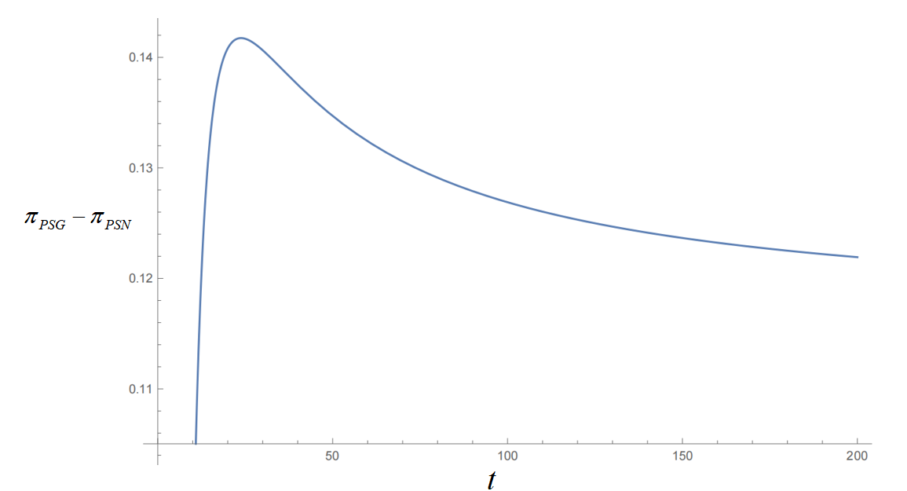

Fig. 2. The effect of time on platform decisions when superior firm A manipulates alone. (, , , , , , )

* 1. Discussion

To study both firms’ optimal manipulation and the platform’s optimal governance measures under different conditions, we analyze the preference order of all the possible equilibria in terms of their profits. When the platform chooses to govern, four possible equilibria for firms arise: (i) both firms choose not to manipulate reviews, denoted as (N, N); (ii) the superior firm chooses to manipulate reviews alone, denoted as (M, N); (iii) the inferior firm chooses to manipulate reviews alone, denoted as (N, M); and (iv) both firms choose to manipulate reviews, denoted as (M, M). For example, for (M, N) to be the equilibrium, we should ensure that neither firm has an incentive to deviate from their current manipulation levels; that is, the firms’ profits should satisfy  and , respectively. We can now summarize the conditions for each possible equilibrium in Fig. 3.

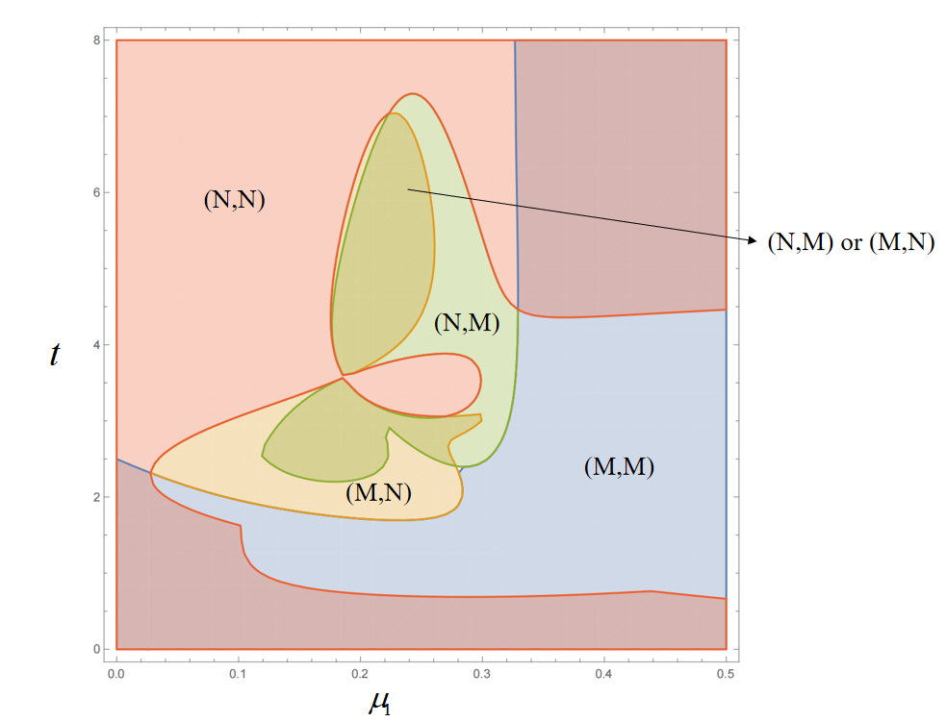

Fig. 3. Firms’ optimal manipulation levels under the values of the unit manipulation cost  and the time .

Through a numerical substitution, we illustrate the decision-making processes of firms under platform governance when , , , , , and . The impacts of the unit manipulation cost and time on the firms’ optimal manipulation levels are shown in Fig. 3. This figure also shows the impact of time on the manipulation behavior of both firms. Initially, firms choose to engage in manipulation to increase their profits. However, as time progresses, both firms tend to avoid manipulation. This shift occurs for two reasons. First, the presence of governance significantly weakens the effectiveness of manipulation, thus reducing its overall impact on firms’ behaviors. Second, as time progresses, the platform is likely to increase governance intensity, thereby imposing additional costs on firms and gradually diminishing the profitability of manipulation, thus leading to a decreased incentive for firms to engage in such practices.

Furthermore, Fig. 3 reveals that, contrary to our expectations, as the unit cost of manipulation v increases, both firms become more inclined to manipulate. This is due to the results derived from Sections 4.2 to 4.4, which indicate an inverse relationship between the manipulation effort  and the unit cost of manipulation . Additionally, the costs associated with manipulation are represented as , highlighting that  has a more significant impact on costs than the unit cost of manipulation . Thus, as  increases, the marginal cost incurred by firms for manipulation actually decreases due to the reduction in , making manipulation more appealing.

For the platform, we investigate its optimal strategy to govern the firms’ manipulation. Similar to firms, the platform also has four equilibriums in terms of profit. For example, for the equilibrium of the (M, N) scenario, the platform can make a positive profit when , , and . Following this line of analysis, we can summarize the conditions for each possible equilibrium in Fig. 4 through a numerical simulation when , , , , , and . As can be seen, each region in Fig. 4 represents the scenario in which the platform’s profit is maximized, given different levels of governance cost  and manipulation cost  under platform governance. To better explore the changes in platform revenues, Fig. 5 illustrates the profit trends under the four manipulation scenarios established in Fig. 4.

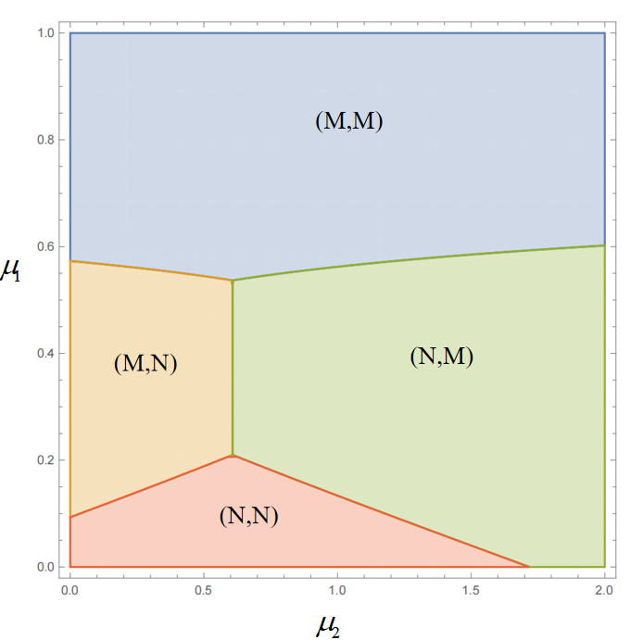

Fig. 4. Impacts of firms’ unit manipulation cost  and platform’s unit governance cost  on the platform’s optimal control strategy.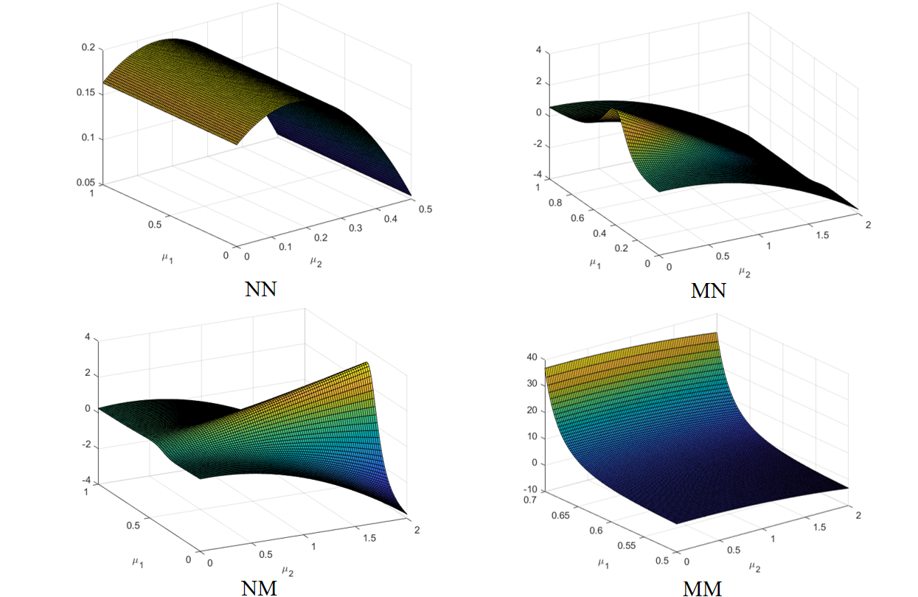

Fig. 5. The profit trends of the platform based on the firms’ unit manipulation cost  and platform’s unit governance cost  under four manipulation scenarios.

From Figs. 4 and 5, we can see that when there is no review manipulation for both firms (i.e., (N, N) scenario), a small governance intensity  (making  with Eq. (14)) is necessary to attract online consumers to use the platform. However, after a critical threshold, an increase in the unit governance cost (i.e. ) leads to higher governance expenses for the platform. Consequently, the platform’s profit will gradually decrease. When only the superior firm A engages in manipulation (i.e., the (M, N) scenario), the platform can reduce its unit manipulation cost to maximize the benefits derived from governance. This is because, as the superior firm A increases its market share through manipulation, this generates more sales and higher commissions for the platform. Moreover, A’s price is higher than B’s, as mentioned previously, meaning that the increase in A’s demand has a greater positive impact on the platform than the decrease in B’s demand. However, if the governance is too strict, it may suppress A’s incentives, ultimately reducing the platform’s commission income. Therefore, in this scenario, the platform is likely to adopt small governance with a small , thus leading to a small governance intensity to ensure that A’s competitiveness is not hindered by maintaining market balance. This situation ultimately maximizes firm A’s profit.

When only the inferior firm B engages in manipulation (i.e., the (N, M) scenario), the platform can maximize its profit with a large. In contrast to the (N, N) and (M, N) scenarios, manipulation by firm B alone results in an increase in B’s demand while decreasing A’s demand simultaneously. However, given that A’s price is higher than B, the overall effect of manipulation leads to a reduction in revenue for the platform. Therefore, the platform should implement stricter governance intensity with a large(also making a large ). This strict governance will not only reduce the manipulation done by firm B, thus decreasing the loss in demand for firm A, but will also enhance consumers’ trust in the platform, helping maintain long-term market competitiveness and sustained platform revenues.

Moreover, based on our previous analysis, as  increases, it will decrease the level of manipulation, thereby driving both firms to opt for manipulation due to the overall lower costs of manipulation and penalties. At this time, the platform will also achieve higher profits than in the other three manipulation scenarios. This is because, when  is large, the increase in demand resulting from the manipulations done by firms A and B is limited due to the small manipulation effort. However, when both firms engage in manipulation (i.e., the (M, M) scenario), this increases the demand for both parties. Thus, the platform can simultaneously earn additional commissions from the sales of both firms, making the profits from joint manipulation greater than those from the sole manipulation and no manipulation scenarios.

1. Conclusion
   1. Research findings

This paper constructs a two-stage, three-player game model to study the effects of platform governance on firms’ review manipulation. By developing profit functions for the superior firm, the inferior firm, and the platform under different review manipulation scenarios, we discover several findings to understand the impact of platform governance on review manipulation.

First, firms can still profit from manipulation despite the presence of platform governance. In fact, even when platform governance is present, both superior and inferior firms can benefit from engaging in review manipulation. Superior firms, on the one hand, with their strong perceived quality advantage, may strategically manipulate reviews to further expand their market dominance. Inferior firms, on the other hand, may resort to manipulation to mitigate the gap created by negative perceptions of quality in unmanipulated reviews. Thus, our quantitative analysis reveals that governance, while effective in restricting manipulation, cannot fully eliminate the strategic advantages that firms derive from manipulating reviews.

Second, manipulation does not necessarily harm platform profits. This finding is in line with previous studies [12], which revealed that some e-commerce platforms acquiesce to online review manipulations because they can benefit from it. Contrary to conventional assumptions, our findings indicate that review manipulation does not inherently reduce platform profits. In fact, platforms may benefit financially from allowing some degree of manipulation, especially when their revenue model is commission-based. This finding is consistent with the study of Long and Liu [23]. Under specific conditions, platforms can achieve what we call “governance profit maximization,” where they implement governance not merely to curb manipulation but to optimize their own profitability. In the current study, the platform’s ability to balance the cost of governance with the revenues generated from firms engaged in manipulation is crucial to this mechanism. Thus, governance strategies can be both a protective measure and a means to sustain platform growth.

Third, platform governance is a mechanism to resolve the so-called prisoner’s dilemma. One of the core findings is that platform governance plays a critical role in resolving this dilemma, which often traps competitive firms. In the absence of governance, firms—whether superior or inferior—are compelled to engage in review manipulation due to competitive pressures. This mutual manipulation leads to suboptimal outcomes for both parties. However, when the platform imposes governance measures, firms are disincentivized from manipulating, as the associated penalties and costs outweigh the potential short-term gains. Thus, we can say that governance provides firms with an opportunity to escape the destructive cycle of competitive manipulation. However, we also find that this mechanism does not always hold. In Section 4.5, we demonstrate that, even with platform governance, within certain ranges, manipulation is not the optimal strategy for firms when they both choose to engage in it. From a broader perspective, this behavior can lead them into a prisoner’s dilemma.

In addition, by incorporating time into our model, we also analyze the impact of time on platform governance. The interaction between platform governance and firm manipulation is dynamic and evolves over time. In the early stages, platforms may delay implementing governance to benefit from the initial influx of consumers brought on by manipulated reviews. However, as time progresses and manipulation becomes more evident, the platform is likely to introduce governance measures. This transition is driven by the long-term necessity of maintaining consumer trust and market integrity, eventually outweighing short-term revenue gains from unfiltered manipulation. Our simulations demonstrate that, over time, the benefits of governance stabilize, while the platform’s profitability remains robust due to enhanced consumer trust.

* 1. Theoretical contributions

From a theoretical perspective, the findings of this study make several contributions to the current literature. First, one of the key theoretical contributions is the integration of platform governance into the analysis of competitive firm behaviors. Previous studies have predominantly examined online review manipulation in isolation [2,3], focusing either on the effects of manipulation between firms or on platform governance as a separate regulatory mechanism. By embedding the platform as an active player in a three-party game model, the present study advances the understanding of how platforms influence the strategic decisions of competing firms engaged in review manipulation. Therefore, such an approach provides a more comprehensive view of the interplay between platform governance and market competition.

Second, this paper considers the economic interests behind the decision to implement platform governance. Unlike the existing literature that tends to treat platform governance as a purely regulatory mechanism, this study explores the economic motivations behind platform governance decisions. In particular, this work demonstrates that platforms do not merely impose governance to curb manipulative behavior but also weigh governance against their own profitability. Thus, by modeling the platform as a strategic actor driven by economic incentives, the current research adds depth to the understanding of how platforms balance short-term profits with long-term sustainability. In doing so, the present work offers fresh insights into the economic rationale behind governance strategies, which have not been discussed in previous literature [13].

Third, this paper incorporates time into the model. By integrating a temporal dimension into the analysis, this research enhances the understanding of how strategies evolve over time within the context of platform governance and firm manipulation. Traditional models often provide a static view and fail to capture the dynamic interactions between platforms and firms. In comparison, this study shows that the timing of governance implementation affects both firms’ manipulation strategies and platform profitability. Over time, firms’ incentive structures shift as they adapt to governance measures. This change demonstrates that strategic interactions in e-commerce marketplaces are not only about immediate actions but also about long-term planning and adjustments.

* 1. Managerial contributions

We also offer important managerial implications. First, from the platform’s perspective, our study explains why platforms initiate governance. By adopting an economic perspective, we analyze the changes in platform profits before and after governance, as well as derive the optimal governance intensity under different manipulation scenarios. Unlike the conventional view that platform governance is primarily aimed at preventing the negative impact of fraudulent reviews on market order and consumer trust [34,35], our findings reveal that platforms can strategically balance governance intensity and revenue to achieve governance profit maximization. In other words, platforms do not necessarily need to eradicate all fraudulent reviews. Instead, they can implement moderate governance that allows certain firms to continue engaging in review manipulation to varying degrees, thereby maximizing their own profitability without significantly undermining overall market trust. This insight provides e-commerce platforms with a new governance approach—dynamically adjusting the intensity of governance to enhance market fairness while optimizing their business models. Furthermore, our study highlights the role of time in governance effectiveness. In particular, we find that governance intensity does not remain static but rather gradually strengthens over time. This finding has important managerial implications for e-commerce platforms: Rather than imposing rigid, one-size-fits-all governance measures, platforms should adopt adaptive governance strategies that evolve with market conditions and governance costs, thus ensuring an optimal balance between governance expenses and revenue generation.

Second, from the perspective of competitive firms, our study provides strategic insights for firms operating in highly competitive environments. Through our three-player game model, we reveal that that in the presence of platform governance, firms do not necessarily need to engage in review manipulation to remain competitive, even if their rivals do so. We find that platform governance effectively reduces the necessity of manipulation driven by competitive pressure, thereby reducing the risk of firms falling into a prisoner’s dilemma. This finding has significant implications for corporate decision-making, as it suggests that firms should prioritize long-term brand reputation over short-term gains from review manipulation, particularly in intensely competitive markets.

Third, from the perspective of the platform ecosystem, our study uncovers the dynamic interactions among platforms and firms, emphasizing the profound impact of governance on market equilibrium. While review manipulation may temporarily boost platform and firm revenues, effective governance is crucial for maintaining a healthy and sustainable platform ecosystem in the long run. Our findings indicate that platforms may initially tolerate a certain degree of manipulation to attract user traffic and stimulate transactions. However, as time progresses, they must gradually strengthen governance measures to uphold consumer trust and ensure market fairness. Therefore, when designing governance policies, platforms should go beyond short-term profit considerations and incorporate the long-term stability of the ecosystem into their strategic planning. This approach enables platforms to achieve sustainable profitability, foster user loyalty, and support the long-term growth of e-commerce markets.

* 1. Limitations and future works

This study has several research limitations. First, this paper only considers commissions from firms when calculating platform revenue; however, in some real cases, platform revenue may contain other items, such as advertising and membership fees. Thus, future research could verify the effect of platform governance on review manipulation by considering more items in platform revenue.

Second, when considering consumer information sources, we considered only online reviews and did not consider other factors influencing consumer purchasing decisions, such as third-party information or peer recommendations. Furthermore, we did not consider the possibility of consumer-identifying manipulation. In the future, we will further refine the consumer demand function to better align with real-life conditions.

Third, in the current model, consumers are treated as passive participants whose decisions are solely based on the perceived quality indicated by online reviews. However, consumers often act as strategic players who carefully consider their purchasing decisions based on a broader context, including their expectations about other consumers’ behaviors and the platform’s governance strategies. Future studies should thus explore the impact of consumer behavior by modeling consumers as strategic decision-makers, thereby bringing some interesting findings.

Finally, the present study only used a two-stage game model to analyze the interactions between the platform and the firms. Thus, future research could benefit from adopting a multistage game framework that allows for continuous adaptation and iterative decision-making. In such a model, the platform could respond dynamically to the firms’ strategic choices, thus modifying its governance strategies based on observed manipulative behaviors.

1. People’s Daily. 84.7% of respondents confirm that fake product reviews greatly impact platform credibility. Online: http://finance.people.com.cn/n1/2021/0318/c1004-32054694.html.
2. Trustpilot. The critical role of reviews in Internet trust. Online: https://business.trustpilot.com/guides-reports/build-trusted-brand/the-critical-role-of-reviews-in-internet-trust.
3. Tracy Qu. Amazon closes 3,000 Chinese-brand online stores in campaign against fake reviews. Online: https://www.scmp.com/tech/big-tech/article/3149203/amazon-closes-3000-chinese-brand-online-stores-campaign-against-fake.
4. Yelp Inc. Survey reveals what makes reviews trustworthy to consumers. Online: https://blog.yelp.com/news/survey-reveals-what-makes-reviews-trustworthy-to-consumers/.
5. Kelly Johnston. The best reason to stop review manipulation in 2022. Online: https://riverbendconsulting.com/blog/stop-review-manipulation-2022/.
6. Center CINI. The 53rd statistical report on China’s internet development. Online: https://www.cnnic.com.cn/IDR/ReportDownloads/202405/P020240509518443205347.pdf.